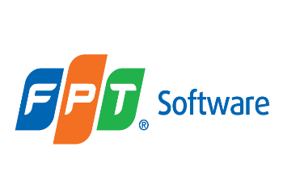

***MVC Application***

**Lab Guides**

|  |  |
| --- | --- |
| Document Code | 25e-BM/HR/HDCV/FSOFT |
| Version | 1.1 |
| Effective Date | 20/11/2012 |

**Hanoi, 07/2019**

RECORD OF CHANGES

|  |  |  |  |  |  |
| --- | --- | --- | --- | --- | --- |
| No | Effective Date | Change Description | Reason | Reviewer | Approver |
|  | 01/Oct/2018 | TuTB create new | Draft |  |  |
|  |  |  |  |  |  |
|  |  |  |  |  |  |
|  |  |  |  |  |  |
|  |  |  |  |  |  |
|  |  |  |  |  |  |
|  |  |  |  |  |  |
|  |  |  |  |  |  |
|  |  |  |  |  |  |
|  |  |  |  |  |  |

Contents

Lab: Create First ASP.NET MVC Application 4

Objectives: 4

Prerequisites: 4

Problem Description: 4

Guidelines: 4

Step 1: Open Visual Studio 4

Step 2: Select **ASP.NET Web Application (.NET Framework)** 4

Step 3: Select MVC project template 5

Step 4: Change the authentication 6

Step 5: Create project 6

Step 6: Run the project for the first time 6

|  |  |
| --- | --- |
|  | **CODE: NEFW.S.L001**  **TYPE: SHORT**  **LOC: 100**  **DURATION: 30 MINUTES** |

# Lab: Create First ASP.NET MVC Application

Objectives:

* Create a new MVC web application using Visual Studio and understand the basic building blocks of the ASP.NET MVC Application..

Prerequisites:

* Download and installs Visual Studio (included .net Framework).

Problem Description:

* N/A

Guidelines:

### Step 1: Open Visual Studio

Select **File menu** -> **New** -> **Project** as shown below.

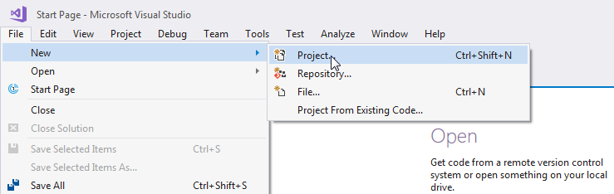

### Step 2: Select **ASP.NET Web Application (.NET Framework)**

From the **New Project** dialog as shown below, expand Visual C# node and select **Web** in the left pane, and then select **ASP.NET Web Application (.NET Framework)** in the middle pane.

Enter the name of your project MyMVCApplication. (You can give any appropriate name for your application). Also, you can change the location of the MVC application by clicking on **Browse..** button.

Finally, click **OK.**

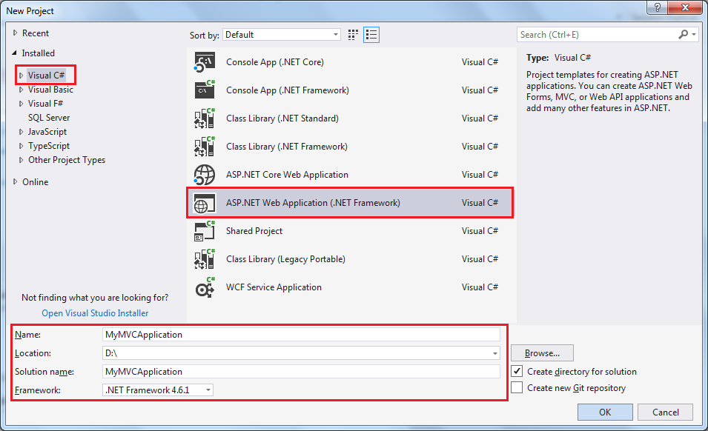

### Step 3: Select MVC project template

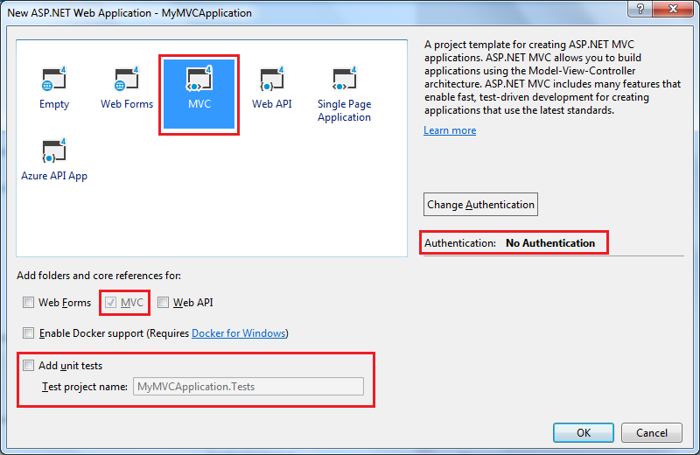

### Step 4: Change the authentication

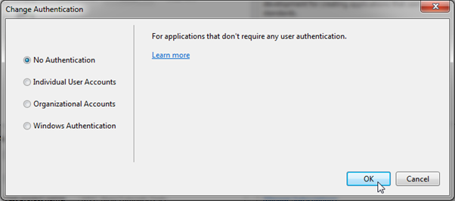

### Step 5: Create project

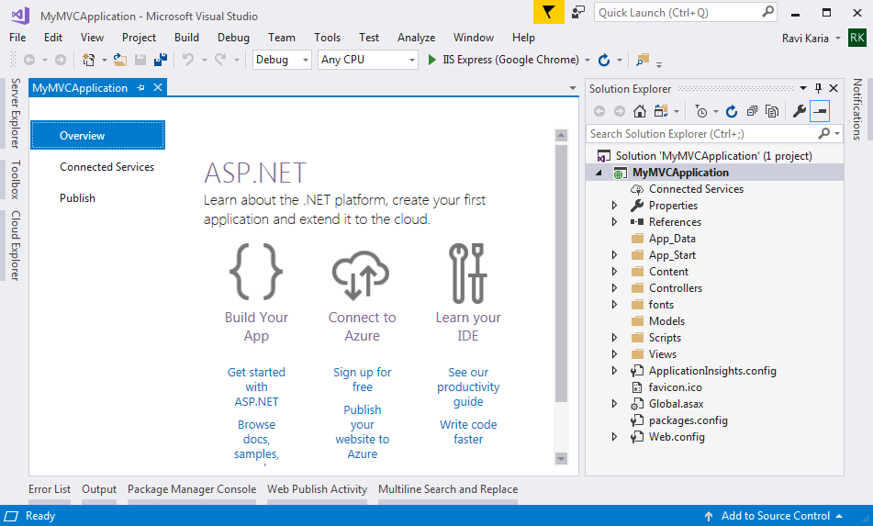

### Step 6: Run the project for the first time

Press F5 to run the project in debug mode or Ctrl + F5 to run the project without debugging. It will open home page in the browser as shown below.

[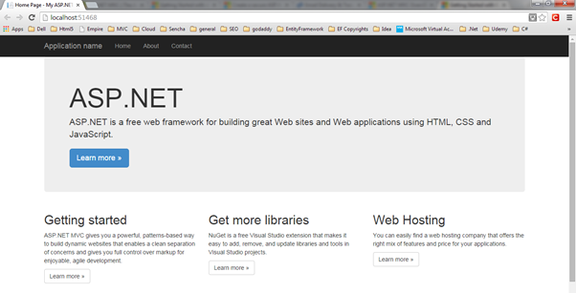](https://www.tutorialsteacher.com/Content/images/mvc/first-mvc-app7.png)